1. Allocation Architectural View type
   1. Deployment Sales System
      1. Primary Presentation

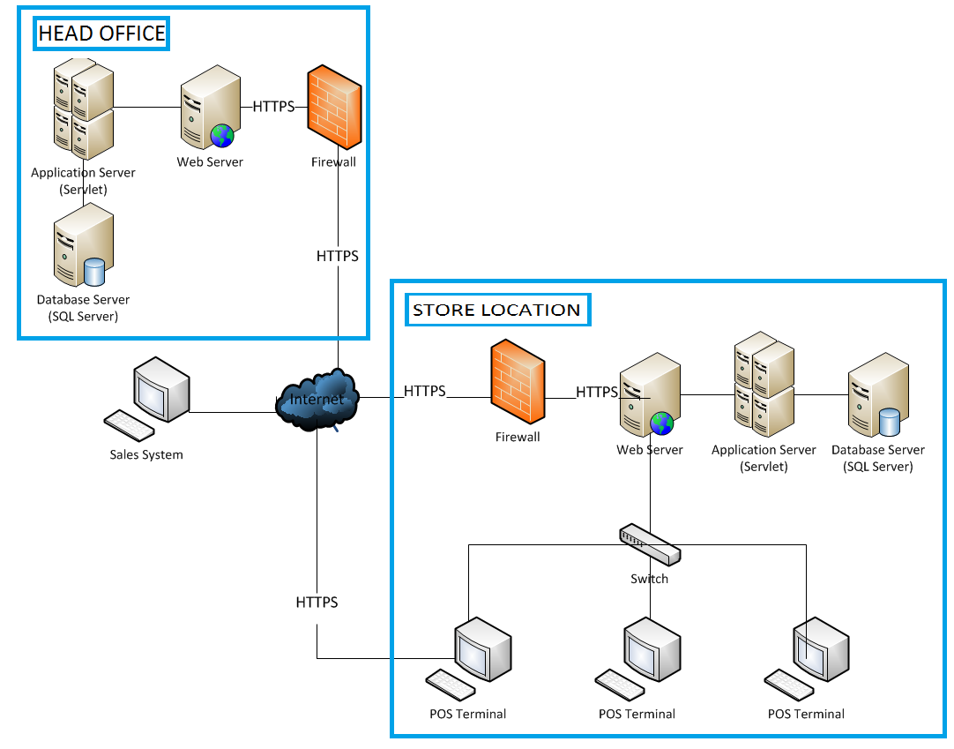



* + 1. Element Catalogue
       1. Elements and their properties

|  |  |
| --- | --- |
| **Element** | **Responsibility** |
| Store Location | Scalable – single station to multiple stores. Allows to manage retail enterprise and monitor retail activities across multi-site operations |
| Sales System | Provide UI to provide the functionality the system for administrator: login, logout, registries item and registries cashier |
| POS terminal | Provide UI to provide the functionality the system for cashier: login, logout, buy item. |

* + - 1. Context diagram



* + - 1. Architecture Background
         1. Design Rational

POS System uses the laptops and requires the distributed configuration, so Client-Server is rational. Client-Server model has some following advantages compared with peer to peer:

* + - Security: data store in servers, because servers should be guarantee those client not access in servers, should be firewall and assign responsibility
    - Performance: it’s very important; we should be assigning following location. Each location have a server, to guarantee access faster
      * 1. Assumptions

The function related to credit card is available by Banking System